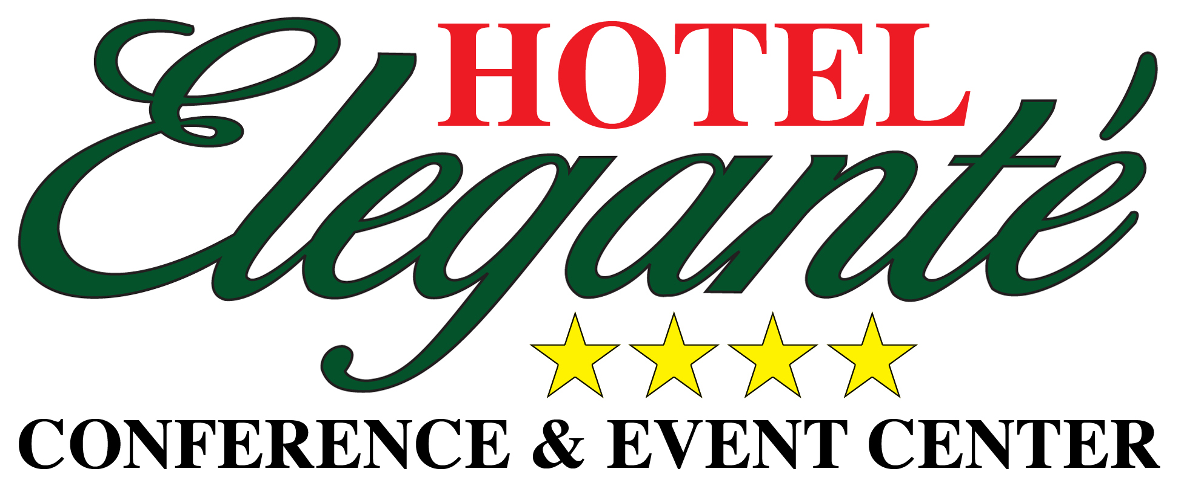

The Hotel Elegante is serving as a host hotel for the
Name of Group: NARPM
Reservation Code: 1390437
We would like to extend a special guestroom rate of
$79.00 (plus tax)
(Based on Availability)
For Reservations, call 719-576-5900
~ ~ ~ ~ ~ ~ ~ ~ ~ ~ ~ ~ ~ ~ ~ ~ ~ ~ ~ ~ ~ ~ ~

Hotel Elegante Conference & Event Center
Indoor Pool and Hot Tub
Rustler’s Country Café
serving Breakfast, Lunch, and Dinner with Children’s Menu available
Outdoor Sports Court
Sweet Tooth serving Starbucks, Colorado Creamery Ice Cream Parlor & Candy Shop
24 hour newly renovated fitness center
Convenient location off I-25, exit 138
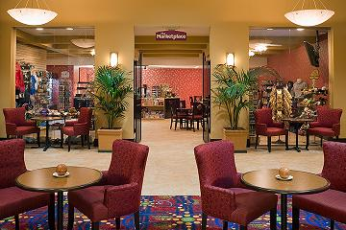
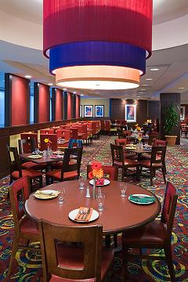
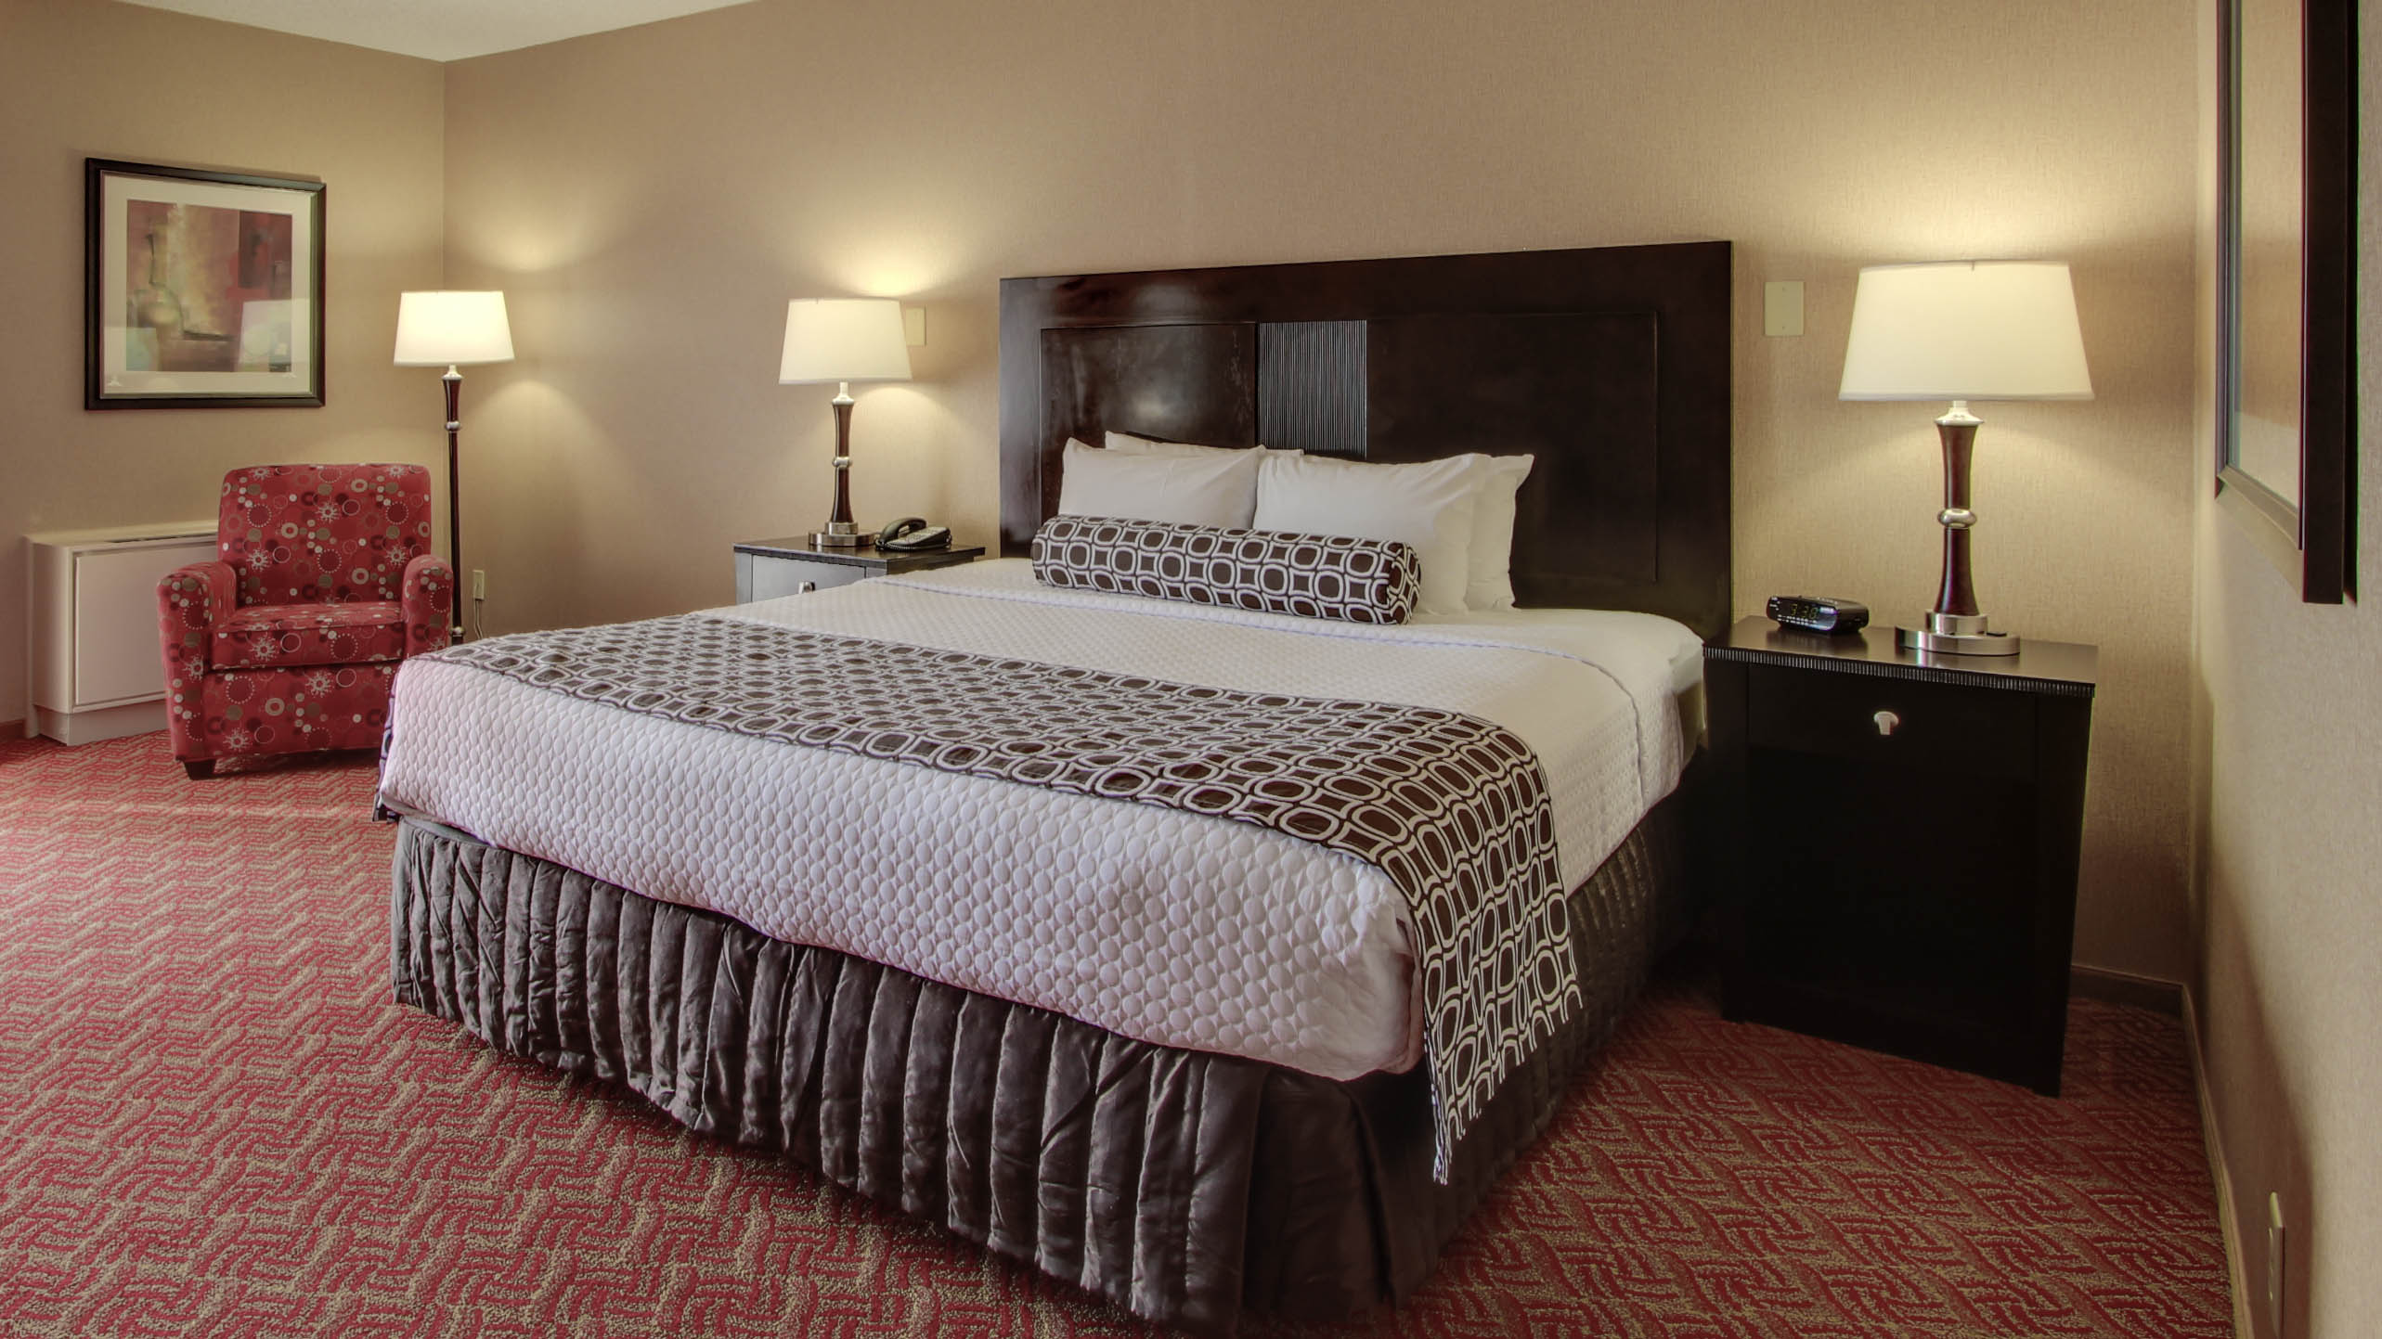
2886 South Circle Drive ** Colorado Springs ** Colorado ** 80906 ** (719) 576-5900

